Python Activity-Based Learning
10 Case Studies — College GitHub Tutorial Style
Student: NAKKA CHARAN TEJA Roll Number: 26000045
Branch: CSE Section: CSE-1
Each case contains the assignment deliverables in a simple tutorial format.
Tutorial Task 12: Attendance Recovery Computation
1. Problem Statement
Calculate a student's attendance percentage and find how many consecutive classes are needed to reach a target.
2. Objectives
1. Calculate the percentage.
2. Use a loop to find extra classes.
3. Assumptions
Use a loop to calculate the minimum extra classes. Assume the student attends every future class.
4. Algorithm
1. Start.
2. Set attended, total, and target.
3. Calculate the current percentage.
4. Count extra classes until the target is reached.
5. Display results.
6. Stop.
5. Flowchart
START
|
v
Input / define data
|
v
Process using conditions or loops
|
v
Display result
|
v
STOP
6. Pseudocode
START
INPUT attended, total, target
CALCULATE percentage
SET extra = 0
WHILE target is not reached
extra = extra + 1
DISPLAY percentage and extra
STOP
7. Python Source Code
attended = 60
total = 80
target = 75
percentage = attended / total * 100
extra = 0
while (attended + extra) / (total + extra) * 100 &lt; target:
extra = extra + 1
print("Current attendance:", percentage, "%")
print("Additional classes needed:", extra)
8. Sample Input
attended = 60, total = 80, target = 75
9. Sample Output
Current attendance: 75.0 %
Additional classes needed: 0
10. Test Cases
1. 60 attended out of 80; target 75% — Expected: 75.0%; 0 extra classes
2. 50 attended out of 80; target 75% — Expected: 40 extra classes
11. Output Screenshot
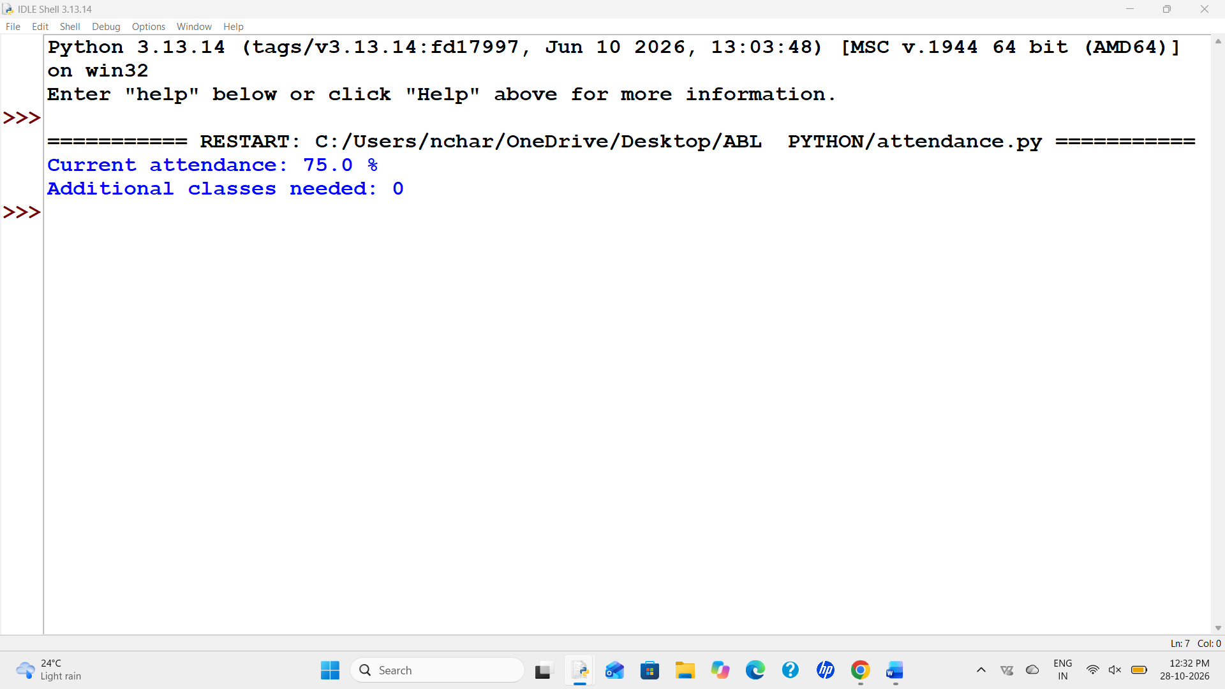
12. Conclusion
The program calculates attendance and the minimum extra classes needed.

Tutorial Task 13: ATM Transaction Sequence Simulation
1. Problem Statement
Process deposits and withdrawals, update the balance, and reject invalid transactions or withdrawals above the balance.
2. Objectives
1. Update the balance after each transaction.
2. Reject invalid amounts and withdrawals above the balance.
3. Assumptions
Amounts must be positive. The opening balance is Rs. 1000.
4. Algorithm
1. Start.
2. Set the opening balance.
3. Read each transaction.
4. Check its type and amount.
5. Update balance or reject it.
6. Display final balance.
7. Stop.
5. Flowchart
START
|
v
Input / define data
|
v
Process using conditions or loops
|
v
Display result
|
v
STOP
6. Pseudocode
START
SET balance = 1000
FOR each transaction
CHECK amount and type
UPDATE balance or reject transaction
END FOR
DISPLAY balance
STOP
7. Python Source Code
balance = 1000
transactions = [("deposit", 500), ("withdraw", 250), ("withdraw", 2000), ("deposit", -20)]
for kind, amount in transactions:
if amount &lt;= 0:
print("Invalid amount:", amount)
elif kind == "deposit":
balance = balance + amount
print("Deposit accepted:", amount)
elif kind == "withdraw":
if amount &lt;= balance:
balance = balance - amount
print("Withdrawal accepted:", amount)
else:
print("Not enough balance:", amount)
print("Final balance:", balance)
8. Sample Input
Opening balance Rs. 1000; deposit 500; withdraw 250; withdraw 2000; deposit -20
9. Sample Output
Deposit accepted: 500
Withdrawal accepted: 250
Not enough balance: 2000
Invalid amount: -20
Final balance: 1250
10. Test Cases
1. Deposit Rs. 500 — Expected: Deposit accepted
2. Withdraw Rs. 2000 — Expected: Rejected because balance is too low
3. Deposit Rs. -20 — Expected: Invalid amount
11. Output Screenshot
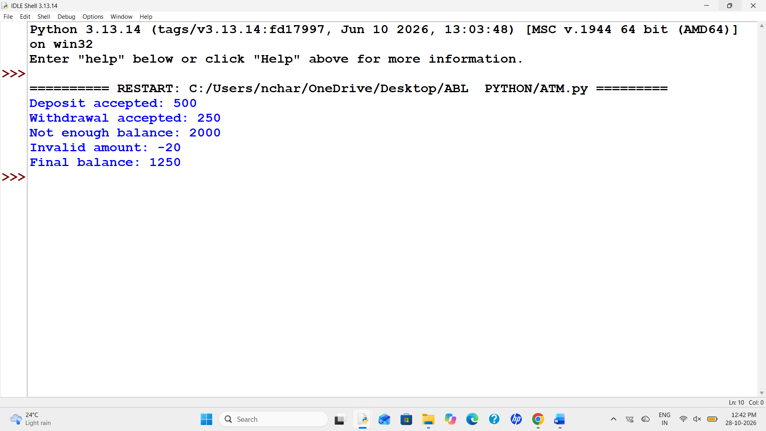
12. Conclusion
The program uses a list, tuples, and conditions to process ATM transactions.

Tutorial Task 26: Nested Loop Examination Seating Generator
1. Problem Statement
Create a seating chart with rows and columns. Reserved seats should not receive student roll numbers.
2. Objectives
1. Use nested loops to create the seating chart.
2. Keep reserved seats marked as RES.
3. Assumptions
The class has 3 rows and 4 columns. Coordinates in the program start at zero.
4. Algorithm
1. Start.
2. Set rows, columns, and reserved positions.
3. Create an empty seating list.
4. Use nested loops to fill seats.
5. Display each row.
6. Stop.
5. Flowchart
START
|
v
Input / define data
|
v
Process using conditions or loops
|
v
Display result
|
v
STOP
6. Pseudocode
START
SET rows and columns
FOR each row
FOR each column
IF reserved, store RES
ELSE store roll number
END FOR
END FOR
DISPLAY seats
STOP
7. Python Source Code
rows = 3
columns = 4
reserved = [(0, 1), (2, 3)]
roll = 101
seats = []
for r in range(rows):
row = []
for c in range(columns):
if (r, c) in reserved:
row.append("RES")
else:
row.append(str(roll))
roll = roll + 1
seats.append(row)
for row in seats:
print(" ".join(row))
8. Sample Input
3 rows, 4 columns; reserved seats at row 1 column 2 and row 3 column 4
9. Sample Output
101 RES 102 103
104 105 106 107
108 109 110 RES
10. Test Cases
1. 3 rows and 4 columns — Expected: 12 positions are displayed
2. Reserved positions — Expected: RES appears at the specified positions
11. Output Screenshot
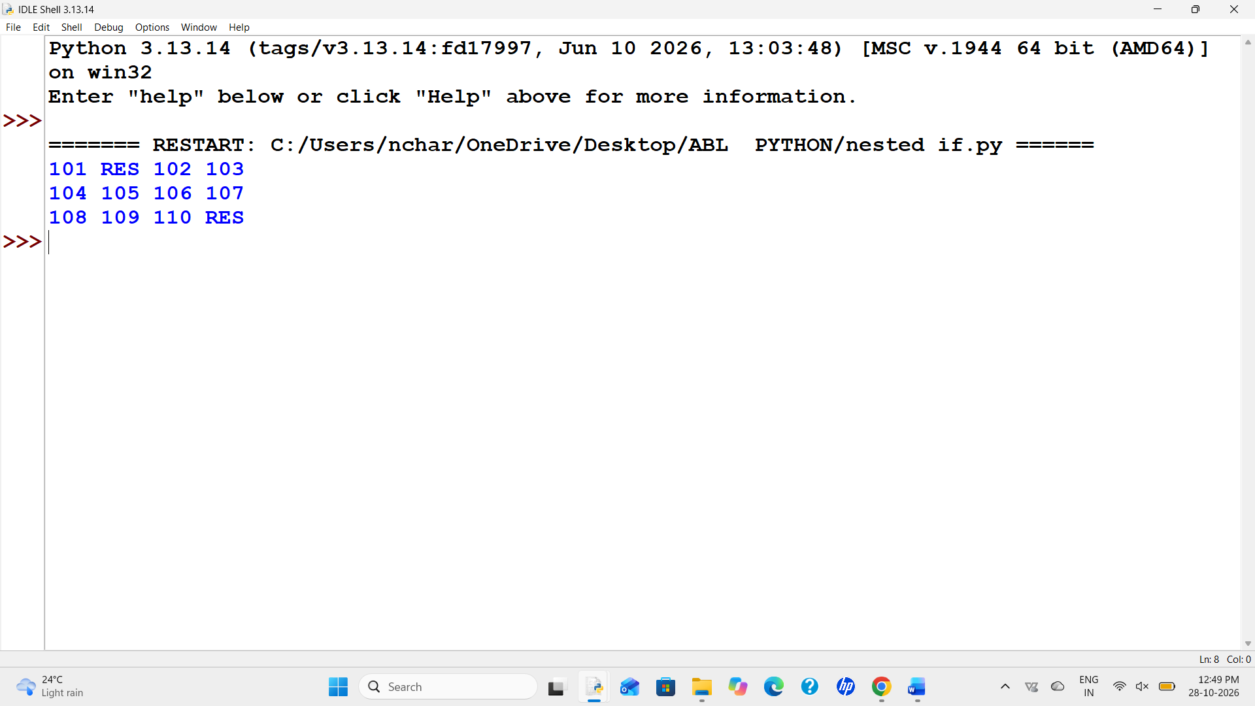
12. Conclusion
The program uses nested loops and a nested list to make a seating chart.

Tutorial Task 27: Advanced Numeric Pattern Generator
1. Problem Statement
Print a hollow diamond pattern using stars and loops.
2. Objectives
1. Practise loops and conditions.
2. Print a hollow diamond.
3. Assumptions
The sample size is 4.
4. Algorithm
1. Start.
2. Set the size.
3. Print the upper half.
4. Print the lower half.
5. Stop.
5. Flowchart
START
|
v
Input / define data
|
v
Process using conditions or loops
|
v
Display result
|
v
STOP
6. Pseudocode
START
SET n
PRINT upper half using a loop
PRINT lower half using a loop
STOP
7. Python Source Code
n = 4
for i in range(1, n + 1):
print(" " * (n - i), end="")
if i == 1:
print("*")
else:
print("*" + " " * (2 * i - 3) + "*")
for i in range(n - 1, 0, -1):
print(" " * (n - i), end="")
if i == 1:
print("*")
else:
print("*" + " " * (2 * i - 3) + "*")
8. Sample Input
n = 4
9. Sample Output
*
* *
* *
* *
* *
* *
*
10. Test Cases
1. n = 4 — Expected: A hollow diamond with 7 rows
2. n = 1 — Expected: A single star
11. Output Screenshot
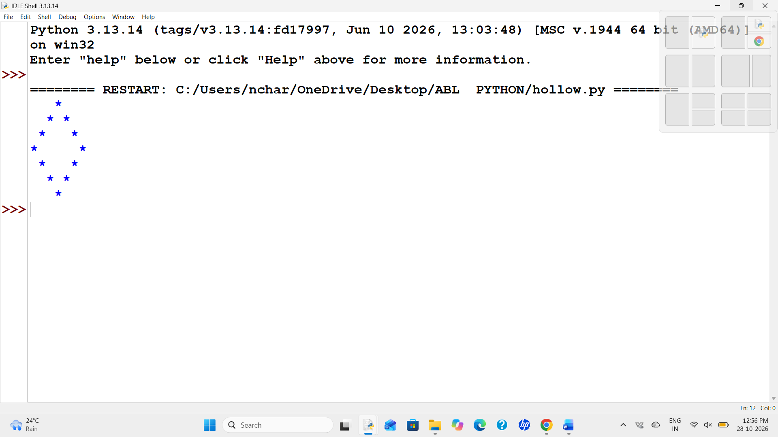
12. Conclusion
The program uses loops and spacing to print a hollow diamond.

Tutorial Task 28: Repeated Transaction Detection
1. Problem Statement
Find duplicate transaction IDs and flag invalid or unusually large amounts.
2. Objectives
1. Find repeated transaction IDs.
2. Check amounts for invalid or large values.
3. Assumptions
Amounts must be positive. Amounts above Rs. 5000 are flagged for review.
4. Algorithm
1. Start.
2. Create transaction records and an empty seen list.
3. Check each ID and amount.
4. Display any issues.
5. Stop.
5. Flowchart
START
|
v
Input / define data
|
v
Process using conditions or loops
|
v
Display result
|
v
STOP
6. Pseudocode
START
SET seen to empty list
FOR each transaction
CHECK duplicate ID
CHECK amount
DISPLAY result
END FOR
STOP
7. Python Source Code
transactions = [("T01", 250), ("T02", 9000), ("T01", 250), ("T03", -10)]
seen = []
for txn_id, amount in transactions:
issues = []
if txn_id in seen:
issues.append("duplicate ID")
else:
seen.append(txn_id)
if amount &lt;= 0:
issues.append("invalid amount")
if amount &gt; 5000:
issues.append("check large amount")
if len(issues) == 0:
print(txn_id, "OK")
else:
print(txn_id, ":", ", ".join(issues))
8. Sample Input
T01 Rs. 250; T02 Rs. 9000; T01 Rs. 250; T03 Rs. -10
9. Sample Output
T01 OK
T02 : check large amount
T01 : duplicate ID
T03 : invalid amount
10. Test Cases
1. Repeated T01 — Expected: Second T01 is marked duplicate
2. Rs. 9000 — Expected: Flagged for review
3. Rs. -10 — Expected: Marked invalid
11. Output Screenshot
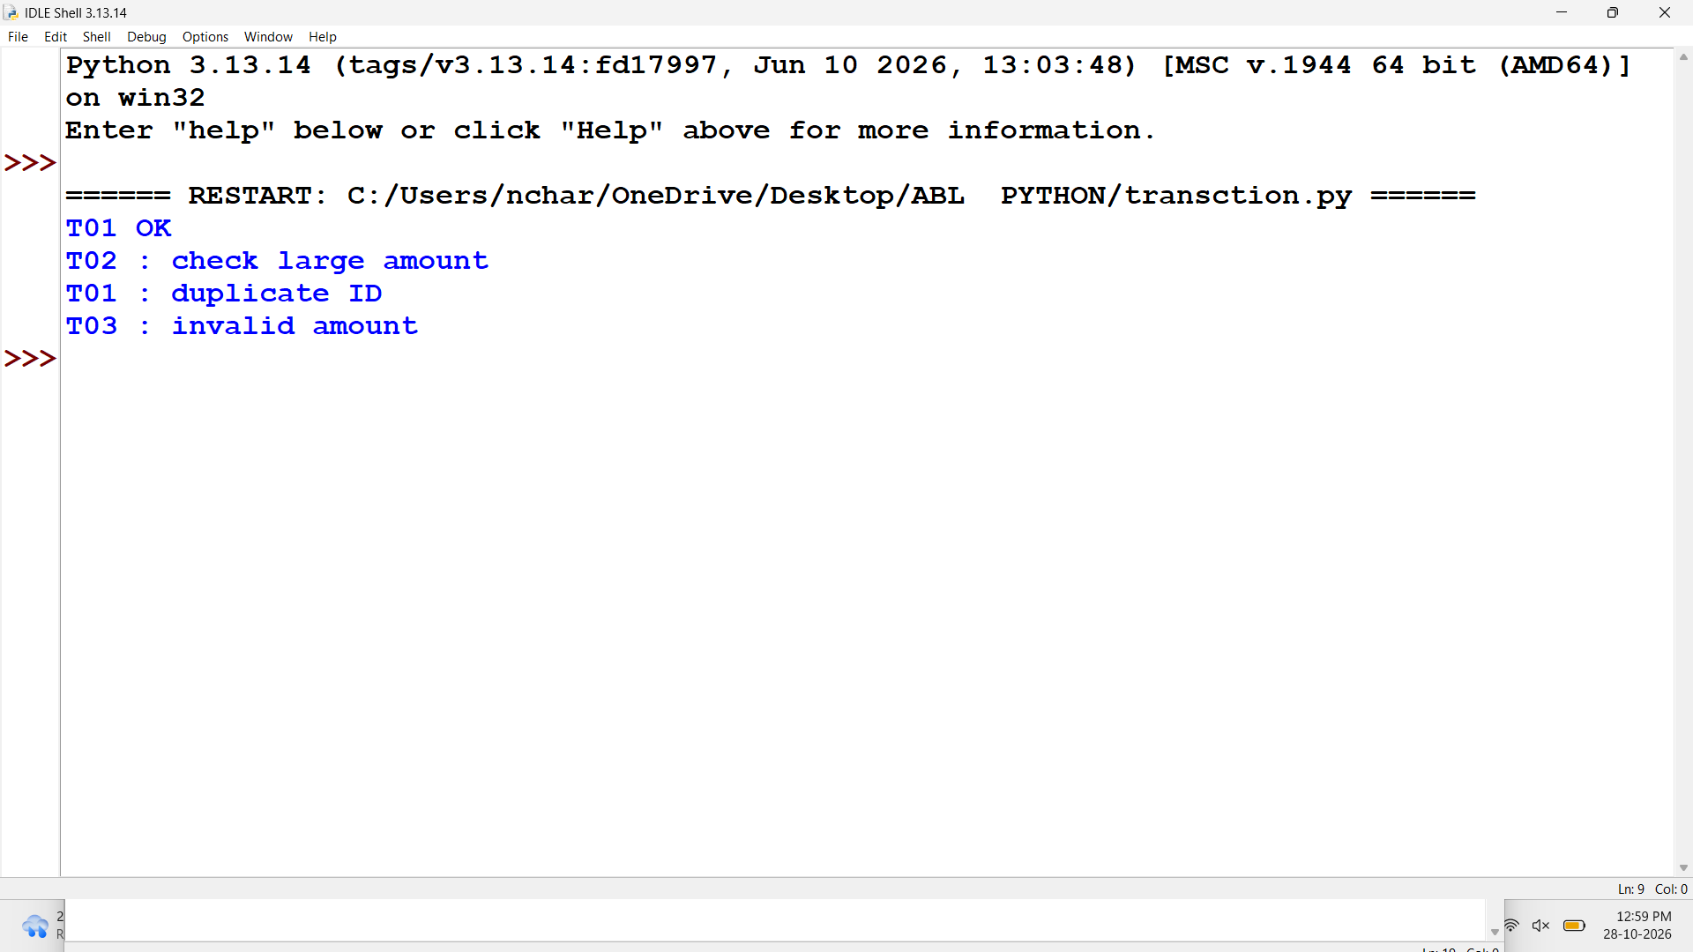
12. Conclusion
The program checks transaction records and reports duplicates and unusual amounts.

Tutorial Task 29: Password Policy Validation Engine
1. Problem Statement
Check sample passwords for minimum length, at least one digit, and at least one uppercase letter.
2. Objectives
1. Check password rules using string operations.
2. Show which rules are not satisfied.
3. Assumptions
Minimum length is 8. This is a classroom example only.
4. Algorithm
1. Start.
2. Set sample passwords.
3. Check length, digit, and uppercase letter.
4. Display valid or failed rules.
5. Stop.
5. Flowchart
START
|
v
Input / define data
|
v
Process using conditions or loops
|
v
Display result
|
v
STOP
6. Pseudocode
START
FOR each password
CHECK length
CHECK digit
CHECK uppercase letter
DISPLAY result
END FOR
STOP
7. Python Source Code

passwords = ["Hello123", "hello", "WELCOME1"]

for password in passwords:
issues = []
if len(password) < 8:
issues.append("too short")
if not any(ch.isdigit() for ch in password):
issues.append("needs a digit")
if not any(ch.isupper() for ch in password):
issues.append("needs an uppercase letter")
if len(issues) == 0:
print(password, "- valid")
else:
print(password, "-", ", ".join(issues))
8. Sample Input
Sample passwords: Hello123, hello, WELCOME1
9. Sample Output
Hello123 - valid
hello - too short, needs a digit, needs an uppercase letter
WELCOME1 - valid
10. Test Cases
1. Hello123 — Expected: Valid
2. hello — Expected: Too short; needs digit and uppercase letter
3. WELCOME1 — Expected: Valid
11. Output Screenshot
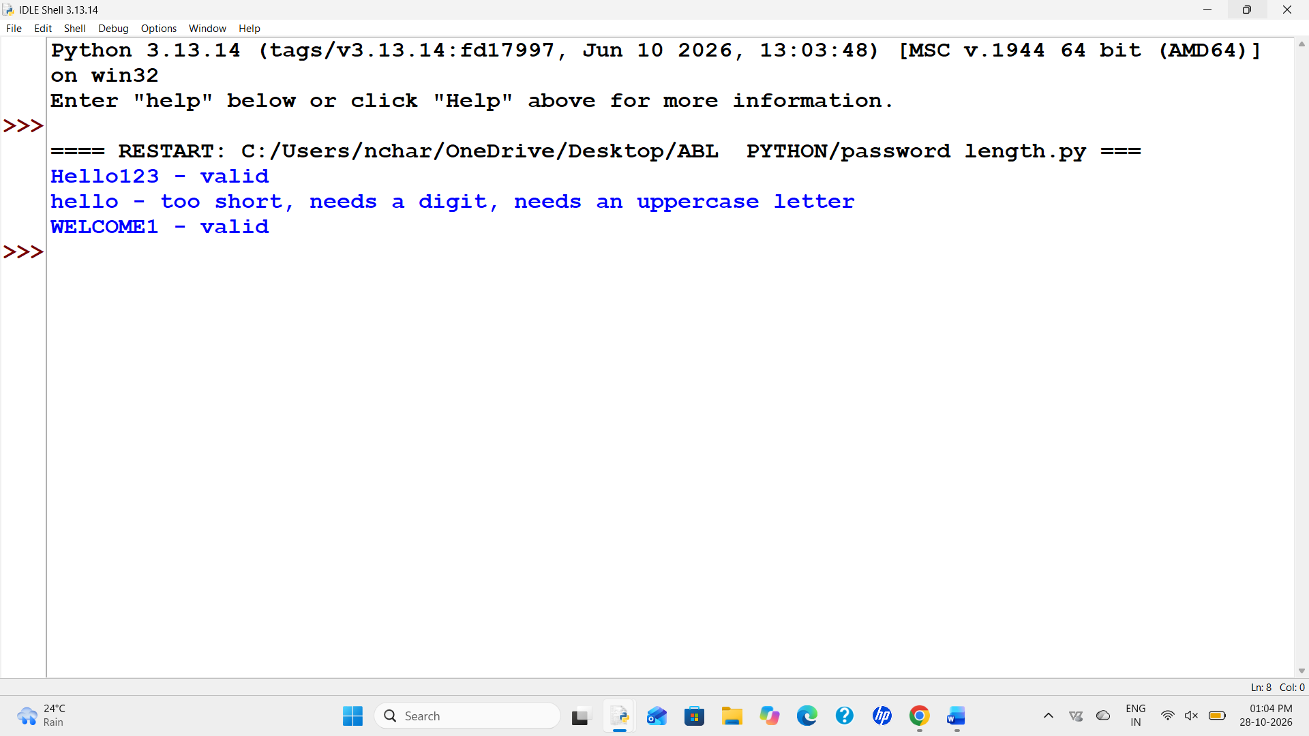
12. Conclusion
The program uses string operations and conditions to check simple password rules.
Tutorial Task 31: String-Based Examination Answer Evaluation
1. Problem Statement
Compare answers with an answer key and calculate correct, wrong, blank, and final marks.
2. Objectives
1. Compare student answers with the key.
2. Calculate marks using the marking rules.
3. Assumptions
Correct answer = +1; wrong answer = -0.25; blank answer = 0.
4. Algorithm
1. Start.
2. Set answer key and responses.
3. Compare each response.
4. Count correct, wrong, and blank answers.
5. Calculate and display score.
6. Stop.
5. Flowchart
START
|
v
Input / define data
|
v
Process using conditions or loops
|
v
Display result
|
v
STOP
6. Pseudocode
START
SET key and answers
FOR each answer
IF blank, count blank
ELSE IF correct, add 1
ELSE subtract 0.25
END FOR
DISPLAY counts and score
STOP
7. Python Source Code

key = ["A", "C", "B", "D", "A"]
answers = ["A", "B", "", "D", "C"]

correct = 0
wrong = 0
blank = 0
score = 0

for i in range(len(key)):
if answers[i] == "":
blank = blank + 1
elif answers[i] == key[i]:
correct = correct + 1
score = score + 1
else:
wrong = wrong + 1
score = score - 0.25

print("Correct answers:", correct)
print("Wrong answers:", wrong)
print("Blank answers:", blank)
print("Final score:", score)
8. Sample Input
Key: A, C, B, D, A; answers: A, B, blank, D, C
9. Sample Output
Correct answers: 2
Wrong answers: 2
Blank answers: 1
Final score: 1.5
10. Test Cases
1. Correct answer — Expected: Adds 1 mark
2. Wrong answer — Expected: Subtracts 0.25 marks
3. Blank answer — Expected: Adds 0 marks
11. Output Screenshot
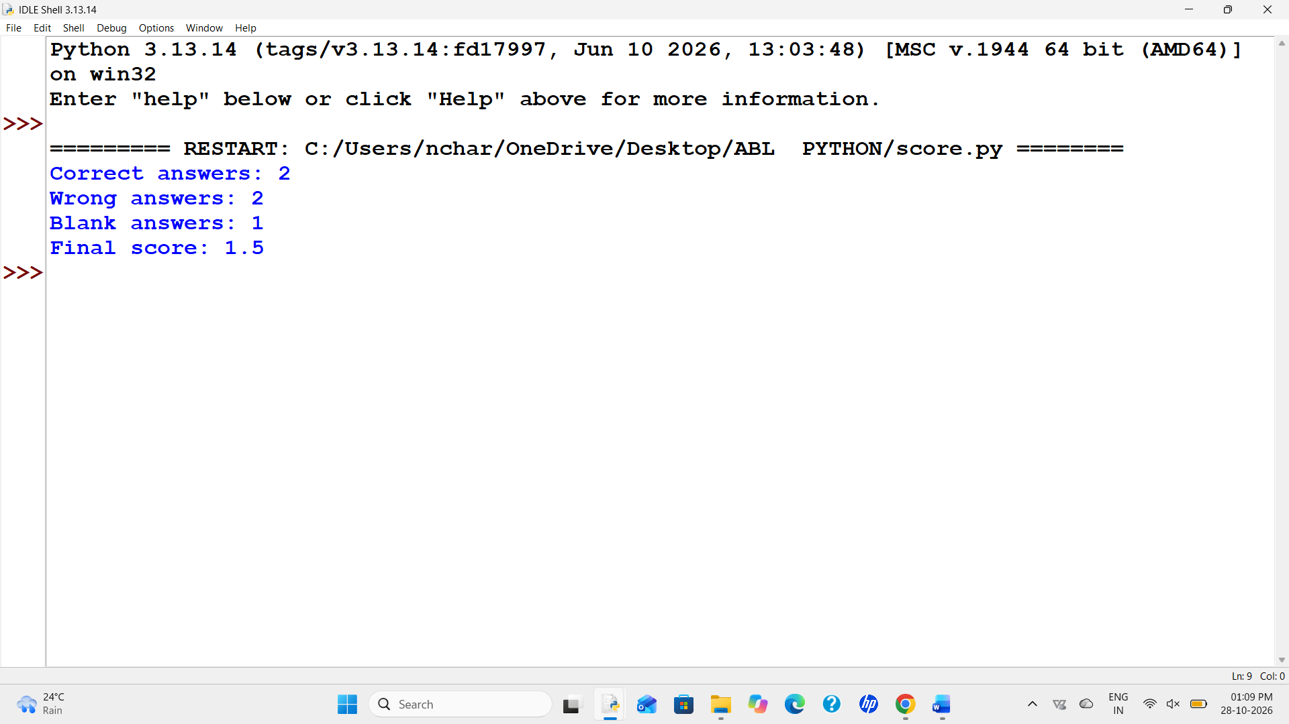
12. Conclusion
The program compares answers and calculates the score using the given marking rule.

Tutorial Task 35: Text Compression Using Character Runs
1. Problem Statement
Compress consecutive repeated characters by writing each character followed by its count. Example: aaabb becomes a3b2.
2. Objectives
1. Use a loop to check neighbouring characters.
2. Count repeated characters and build the result.
3. Assumptions
The sample text is non-empty.
4. Algorithm
1. Start.
2. Set the text and count.
3. Compare each character with the previous one.
4. Add each group and its count to the result.
5. Display the result.
6. Stop.
5. Flowchart
START
|
v
Input / define data
|
v
Process using conditions or loops
|
v
Display result
|
v
STOP
6. Pseudocode
START
SET text and count = 1
FOR each next character
IF same as previous, increase count
ELSE add previous character and count; reset count
END FOR
ADD last character and count
DISPLAY result
STOP
7. Python Source Code
text = "aaabbccccdaa"
result = ""
count = 1
for i in range(1, len(text)):
if text[i] == text[i - 1]:
count = count + 1
else:
result = result + text[i - 1] + str(count)
count = 1
result = result + text[-1] + str(count)
print("Original text:", text)
print("Compressed text:", result)
8. Sample Input
aaabbccccdaa
9. Sample Output
Original text: aaabbccccdaa
Compressed text: a3b2c4d1a2
10. Test Cases
1. aaabb — Expected: a3b2
2. abcd — Expected: a1b1c1d1
3. aaaa — Expected: a4
11. Output Screenshot
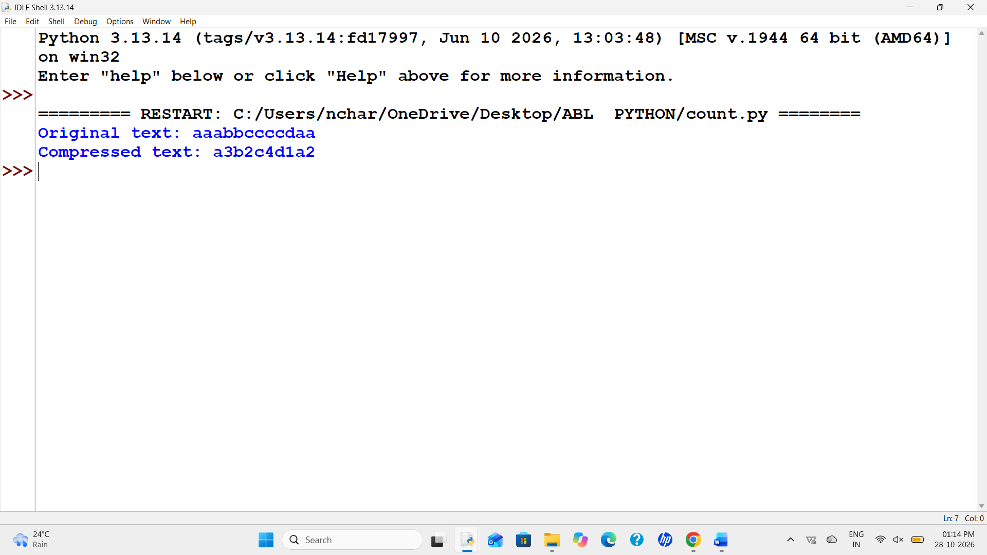
12. Conclusion
The program groups repeated neighbouring characters and displays each group with its count.

Tutorial Task 37: Nested Loop Calendar Generator
1. Problem Statement
Print a simple monthly calendar using the number of days and the weekday on which the month starts.
2. Objectives
1. Use a loop to print each day.
2. Align the first day under the correct weekday.
3. Assumptions
The sample month has 30 days. Weekday numbering is Monday = 0 through Sunday = 6.
4. Algorithm
1. Start.
2. Set number of days and starting weekday.
3. Print weekday headings.
4. Print leading spaces.
5. Print each day and start a new line after Sunday.
6. Stop.
5. Flowchart
START
|
v
Input / define data
|
v
Process using conditions or loops
|
v
Display result
|
v
STOP
6. Pseudocode
START
SET days and start_day
DISPLAY weekday headings
PRINT leading spaces
FOR each day
PRINT day
START new line after Sunday
END FOR
STOP
7. Python Source Code

days = 30
start_day = 2

print("Mon Tue Wed Thu Fri Sat Sun")
print(" " * (start_day * 4), end="")

for day in range(1, days + 1):
print("%3d" % day, end=" ")
if (start_day + day) % 7 == 0:
print()

print()
8. Sample Input
days = 30; start_day = 2 (Monday = 0)
9. Sample Output
Mon Tue Wed Thu Fri Sat Sun
1 2 3 4 5
6 7 8 9 10 11 12
13 14 15 16 17 18 19
20 21 22 23 24 25 26
27 28 29 30
10. Test Cases
1. 30 days starting Wednesday — Expected: Day 1 appears under Wednesday
2. 31 days starting Monday — Expected: All 31 days are printed
11. Output Screenshot
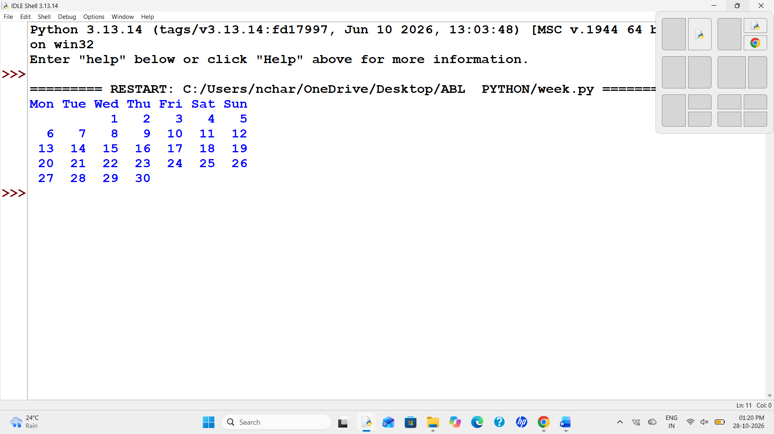
12. Conclusion
The program prints a basic calendar using a starting weekday and loop.

Tutorial Task 42: Student Marks Matrix Analysis
1. Problem Statement
Store student marks in a nested list, calculate totals and averages, and find the student with the highest total.
2. Objectives
1. Store marks in a nested list.
2. Calculate totals and averages and find the top student.
3. Assumptions
Each row represents one student and has three subject marks out of 100.
4. Algorithm
1. Start.
2. Create student names and marks matrix.
3. Calculate each student's total and average.
4. Find the highest total.
5. Display results.
6. Stop.
5. Flowchart
START
|
v
Input / define data
|
v
Process using conditions or loops
|
v
Display result
|
v
STOP
6. Pseudocode
START
SET names and marks matrix
FOR each student
CALCULATE total and average
IF total is highest, save student name
END FOR
DISPLAY top student
STOP
7. Python Source Code

names = ["Asha", "Balu", "Chitra"]
marks = [[78, 82, 91], [65, 70, 68], [90, 94, 89]]

top_name = ""
top_total = -1

for i in range(len(marks)):
total = sum(marks[i])
average = total / len(marks[i])
print(names[i], "Total:", total, "Average:", round(average, 2))

if total > top_total:
top_total = total
top_name = names[i]

print("Top student:", top_name)
print("Highest total:", top_total)
8. Sample Input
Asha: 78, 82, 91; Balu: 65, 70, 68; Chitra: 90, 94, 89
9. Sample Output
Asha Total: 251 Average: 83.67
Balu Total: 203 Average: 67.67
Chitra Total: 273 Average: 91.0
Top student: Chitra
Highest total: 273
10. Test Cases
1. Three marks per student — Expected: Totals and averages are displayed
2. Chitra has the highest total — Expected: Chitra is shown as top student
11. Output Screenshot
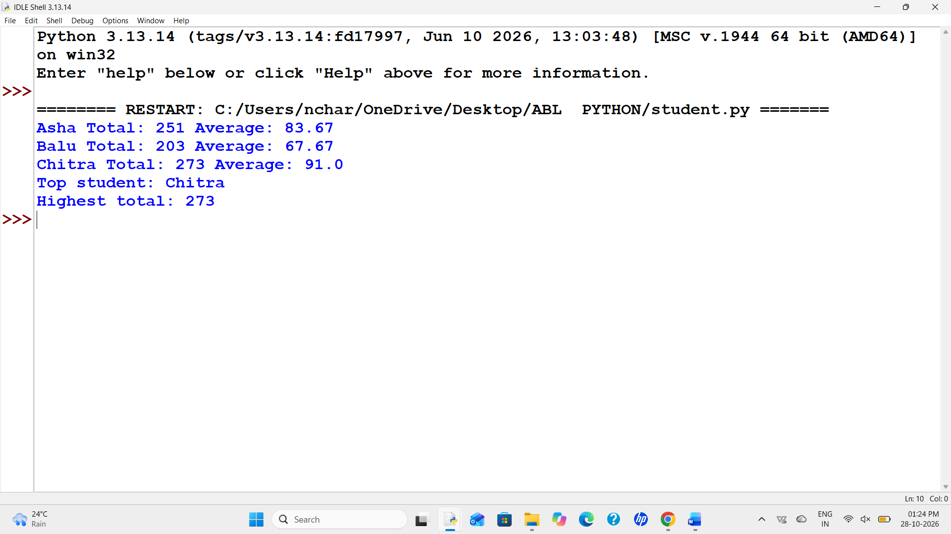
12. Conclusion
The program uses a nested list to calculate totals, averages, and the top student.

